

Six Sigma Project: Full-Time Employment Spending vs. Part-Time Employment Spending

Paige Taylor | Operations Management | Dr. Cindy Stevens | 08/07/2019

**Executive Summary**

* The focus of this study is to evaluate my spending habits when working full-time during March 2019 vs. part-time in June 2019. By reviewing my spend during these periods, I hoped to control my spending and live within the limits of my reduced part-time salary by having a positive net income in June.
* In March, I had a negative net income of $303.70 dollars after expenses. This was the impetus for my June goal.
* In June, I watched my spending closely and ended with a positive net income of $189.97 which allowed me to reach my primary goal.
* To reach my June goal, I needed to reduce these high traveling expenses, I decided to start walking or using public transportation to lower my transportation costs.
* When reviewing the June data, my highest expenses were no longer transportation cost but instead; related to eating out at restaurants and dining.
* To conclude, I was able to recognize I tend to spend more when working full-time. I also realized that having a lower income requires me to analyze my spending habits and lower my overall expenses. I need to identify when there are other ways to obtain the same service at a reduced cost.

**Define Phase**

In this project, I will demonstrate the difference between working full-time vs. part-time and the impact it has on my weekly budget. Understanding your spending is incredibly important for all ages, especially when you are starting out after college.

**Project Impact**

The impact of this project is to decrease my overall spending by recognizing part-time work means half of my full-time pay. This project will also show the difference between full-time employment vs. part-time employment pay. By ensuring I had a positive net income, I will be able to start putting money aside for a Master’s Degree.

**Tools and Quality of Tools Used**

* Bar Graphs: Total Expenses and Revenue, March vs. June Profit/Loss, and a comparison of spending during my full-time and part-time employment
* Pie Chart: Total Expenses per Categories
* Supplemental Works: Income statements for both March and June
* Link: [Google Sheets Page - Monthly Tracking Sheet](https://docs.google.com/spreadsheets/d/1qbT51O5a4uLNII2wA4VWebn7WQ61o3uEq5cusAAVPgw/edit?usp=sharing)

**Problem Statement**

My spending habits have been out of control for some time and I was worried about spending too much while working part-time. By tracking my spending and identifying specific categories I spend the most at, I will be able to decrease my overall expenses.

**Project Scope**

In Scope

* Gain an understanding of how to track finances
* Recognize the impact of working full-time vs. part-time on income
* Identify and decrease the amount of spending

Out of Scope

* Explain to others how to budget
* Have the ability to put money aside for a Master’s Degree

**Project Timeline**

This project includes data from the month of March 2019 during full-time employment and during the month of June 2019 during part-time employment.

**Measure Phase**

*(During this part of the project, I used the following graphs to track data collected during the two months. The information in Supplemental Works houses data that build these graphs.)*

Bar Graph: Used to illustrate the daily amount spent compared to how regularly income arrived in March and June. The graph proves that I spent more regularly than I made money. 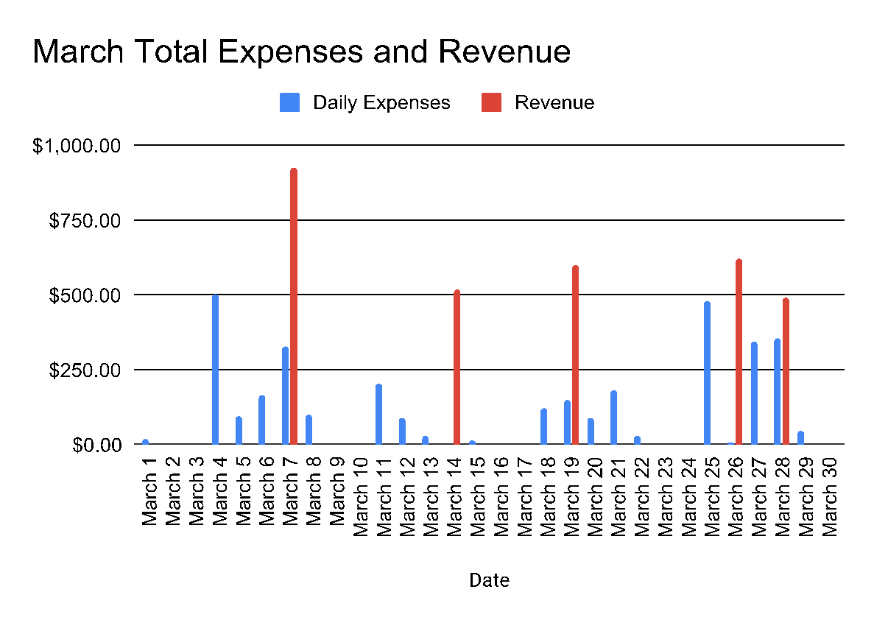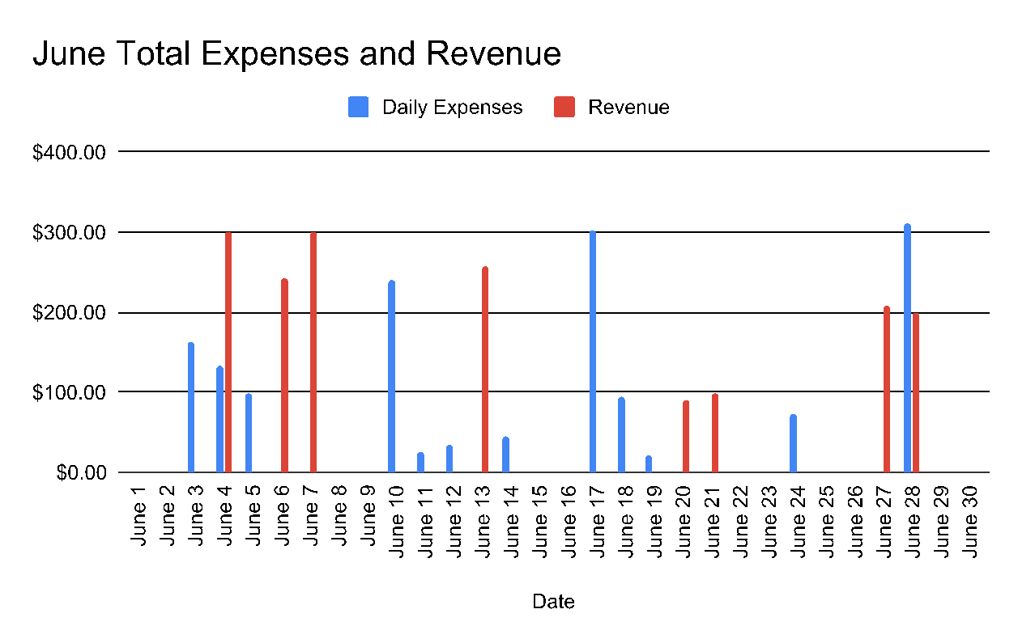

Pie Chart: Used to identify how much was spent during the month by category. In March, I spent the most on travel, totaling $721.41. In June, I spent the most on restaurants and dining, totaling $710.06.

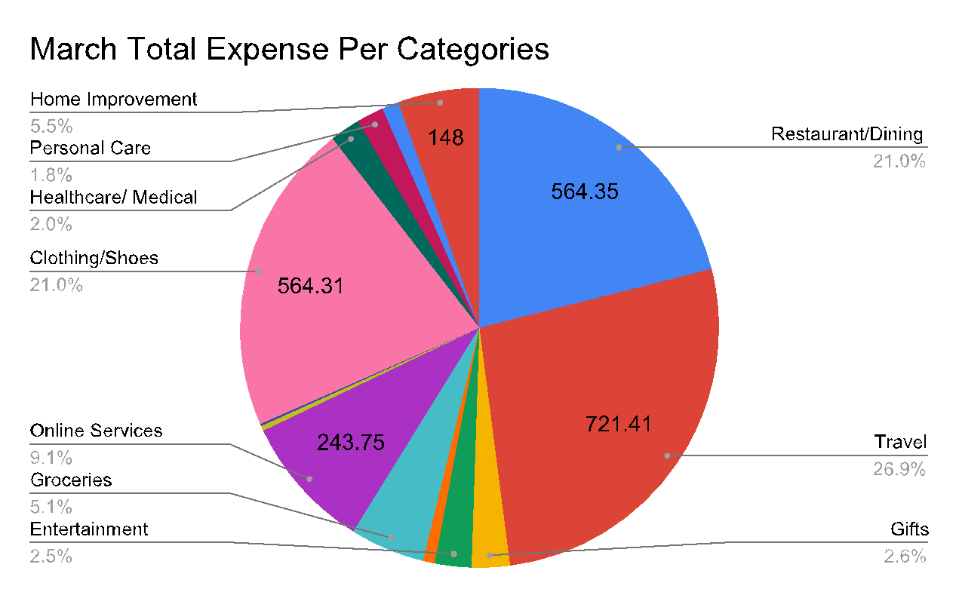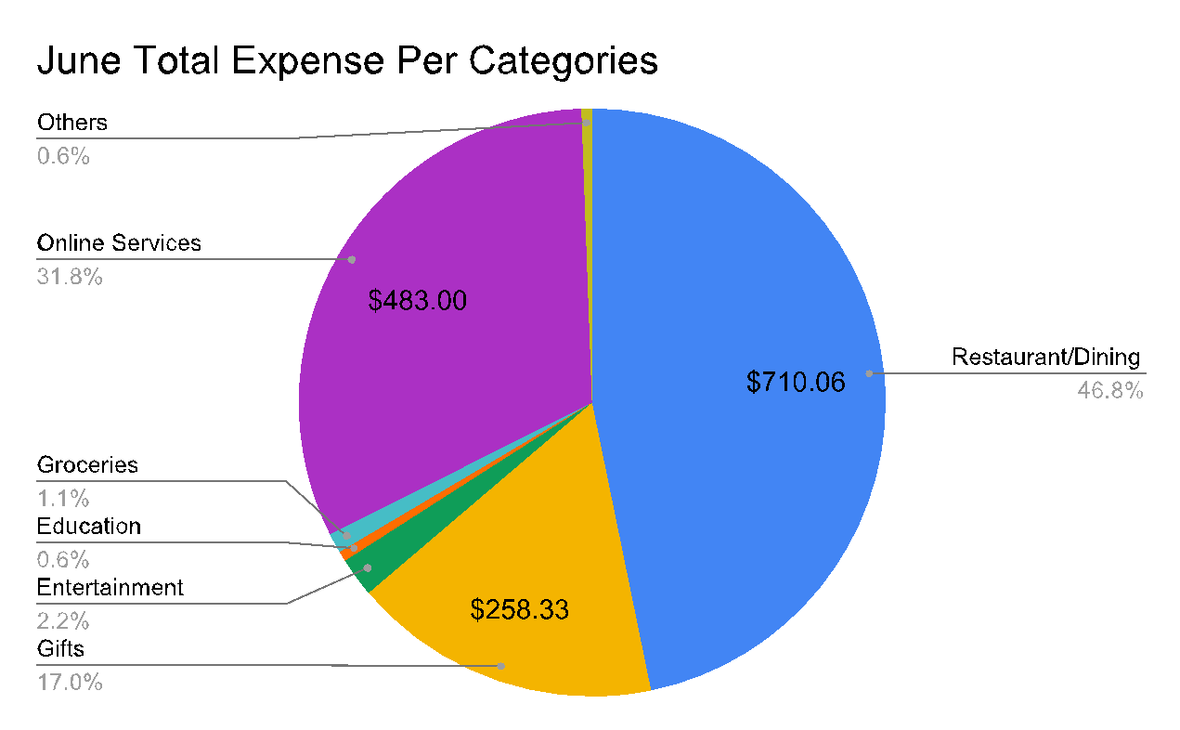

Bar Graph: Used to compare both months profits and losses. It can be said that June, I did better with spending less than in March.

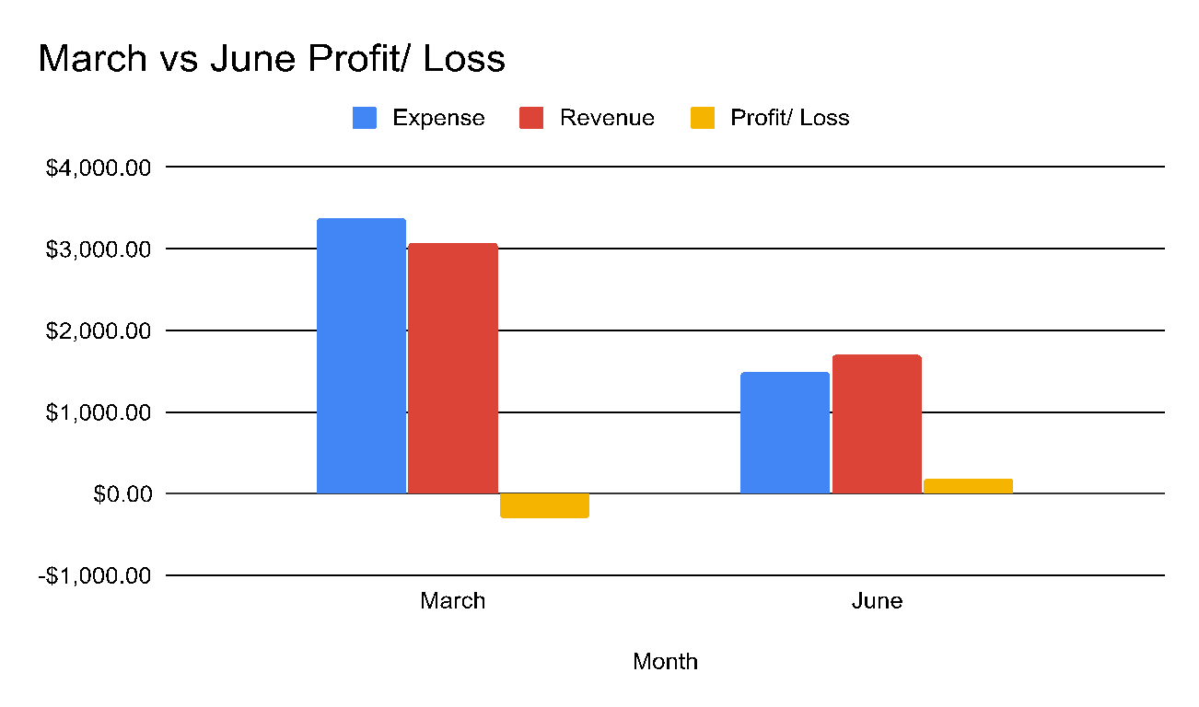



Bar Graph: Used to track the expenses by categories to recognize which expense I need to decrease spending on.

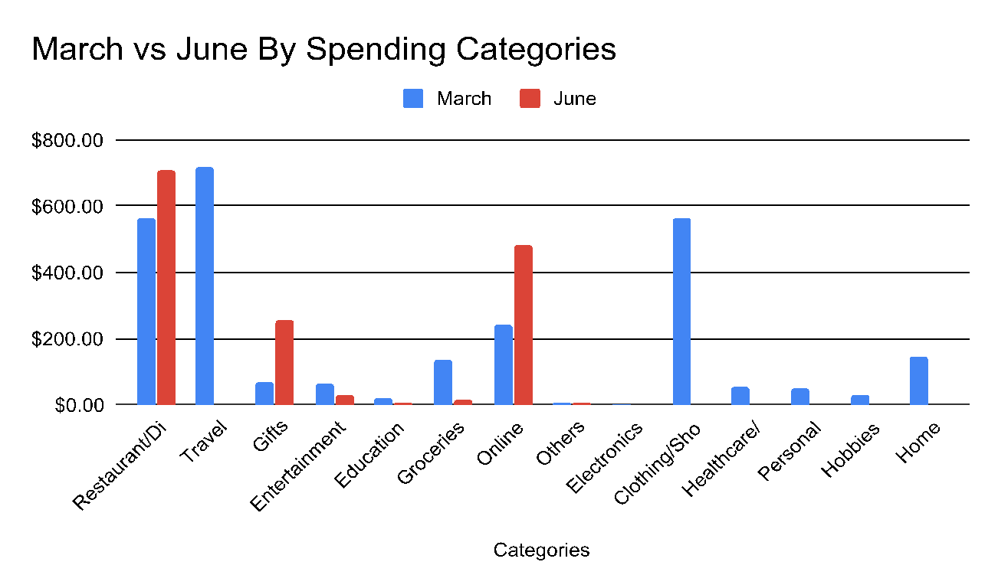

**Analyze Phase**

In the course of this project, I met the goal to decrease my overall spending in June when I worked part-time. I recognized that being part-time I had to reduce my expenses drastically or I would simply run out of money. My highest expense in March was Uber, $311.48. I addressed this in June by walking, riding the T and carpooling and I was able to eliminate the amount of money spent on Travel (Figure 6). While I did recognize I needed to decrease spending on travel, I spent money most days (Figure 2) and increased my spending to $710.06 on restaurants and dining. This was $145.71 more than March’s restaurant and dining expenses. This is due to my dining out during a trip to Paris. While I did increase spending in restaurants, I was able to decrease expenses in other areas including electronics, clothing and shoes, healthcare, personal, hobbies, and home improvements (Figure 6).

**Lessons Learned and Improvements**

Overall I saved money in June, but it did not make up for the loss in March (Figure 5). After completing this project, I can conclude that when I focus on decreasing the highest categories expenses, I will have a positive net income. This project also helped me start to recognize just how much money I was actually spending and value what I spent my money on. I plan to continue to track my spending more closely to ensure I never have another spending month like March. I will be improving keeping my costs much lower so I can increase my net income.

Supplemental Works:

