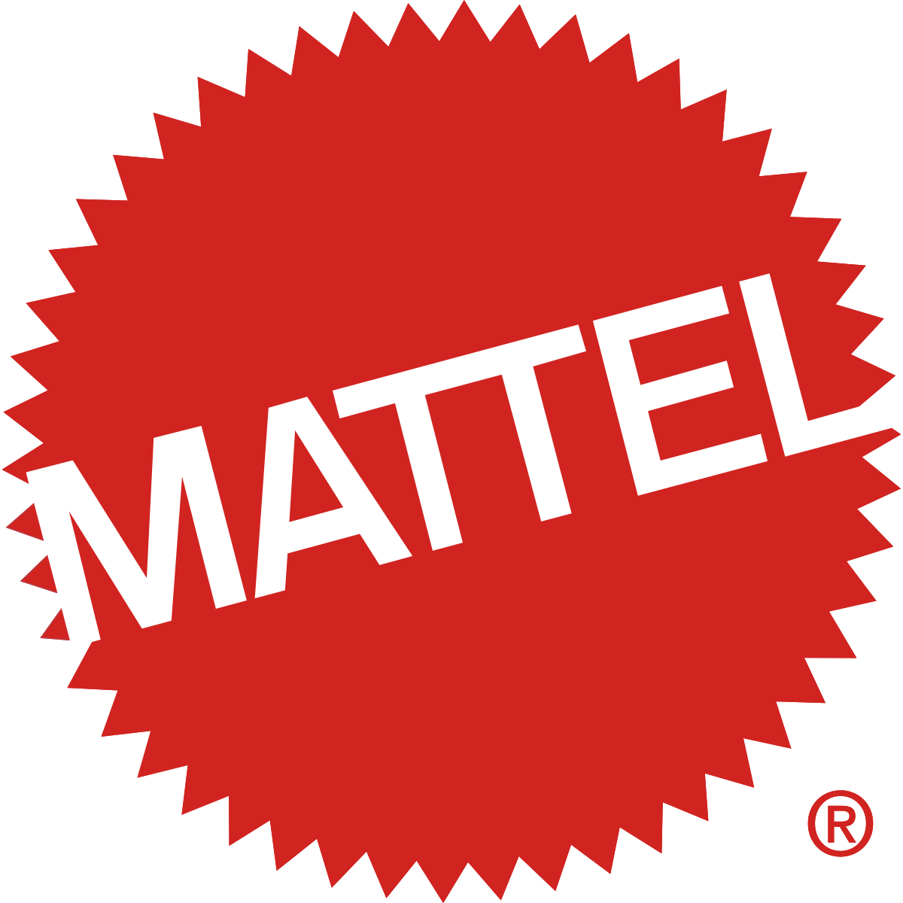

2007 Toy Recall Case Study

By Garrett Dintaman, Paige Taylor, Brandon Black, Griffin Price

Table of Contents

Key Facts of Mattel………………………………………………….……………………3,4

Mattel Main Issues…………………….…………………………………………………4,5

Analysis of Mattel………………………………………………………………………….5

Grey Areas………………………………………………………………………………...5,6

Gap Analysis………………………………………………………………………………...6

Current Situation…………………………………………………………………………..6,7

Recommended Tools of Opperation……………………………………………...……....7 - 9

Recommendation……………………………………………………………………………9

Work Cited…………………………………………………………………………………..10

**Key Facts of Mattel**

The journey of Mattel began modestly in 1944, when Harold Matson and Elliot Handler began to make toys out of a converted garage in California. They named the company Mattel, using letters from their last and first names. Matson sold his share to Elliot Handler and his wife, Ruth Handler, who incorporated the company in 1948. Mattel’s first products were picture frames and doll house furniture.23 Their first big product was a mass-produced, and thus, inexpensive music box, which established Mattel firmly in the toy business. The introduction of Barbie in 1959, and Ken two years later, propelled company growth. The products introduced later such as Hot Wheels went further to establish Mattel’s position as an industry leader. Mattel went public in 1960.

In the 1990s, Mattel made a number of significant acquisitions, including Fisher-Price (1993, leader in preschool segment), Kransco (1994, made battery-powered ride-on vehicles), Tyco (1997, made Tickle Me Elmo and Matchbox cars), Pleasant Company (1998, mail-order firm that made American Girl-brand books, dolls, and clothing), and Bluebird Toys (1998, made toys such as Polly Pocket and The Tiny Disney Collection). Mattel’s acquisition of The Learning Company, a leading educational software maker, in 1999 at a cost of $3.6 billion proved to be troublesome. The company lost money and was later sold. Mattel also made a hostile bid to acquire Hasbro, the second largest toy company. This bid, made in 1996, failed to materialize.

About 45 percent of Mattel’s sales were accounted for by three major buyers: Wal-Mart, Toys’R’Us, and Target. In addition to its principal competitors such as Hasbro and RC2, Mattel also competed with a large number of smaller companies that made toys, video games, and consumer electronics, and published children’s books.

In June 2007, a French direct importer of Mattel’s products, Auchan, performed pre-shipment tests with the help of Intertek, an independent laboratory. These tests revealed that Mattel’s toys, made by a vendor Lee Der Industrial Company, contained lead above the permissible limits. Intertek sent the test results, on June 8, 2007, to Mattel employees in China. Consequently, Mattel employees contacted Lee Der instructing it to correct the problem and provide another sample for testing. Another test by Intertek on June 29, for Auchan, on the same toy produced by Lee Der had passed the test. On June 27, 2007, Mattel’s call center in the United States received a report from a consumer, who informed them that a home test kit found excessive lead in Mattel’s toys. These were also manufactured by Lee Der. Following this, Mattel tested five samples of Lee Der toys and found on July 6 that three of them contained excess lead. As the testing was underway, Auchan informed Mattel on July 3 about lead violations in another toy made by Lee Der. As soon as the test results were out, Mattel employees in China notified Lee Der and stopped accepting products made by Lee Der. Further tests on the toy samples collected from Lee Der were conducted on July 9 in Mattel’s own laboratories, which revealed that nine of the 23 samples of Lee Der toys contained excess lead in surface paint. Mattel’s employees in China notified the senior management team at corporate headquarters on July 12 about the issues with Lee Der products. Following this, Mattel management ordered an immediate suspension of all shipments of products made by Lee Der. Further investigations by Mattel revealed that the nonconforming lead levels were because of a yellow pigment in paint used on portions of toys manufactured by Lee Der.

**Mattel Main Issues:**

Mattel got themselves in hot water because they decided to go cheap and offshore their manufacturing to foreign countries. Those countries have different regulations when it comes to what can be put into the material. China was the primary manufacturer for Mattel’s toys meaning that they supplied the faulty or dangerous toys. Because of their manufacturing ways, Mattel got into trouble with having lead paint in the products as well as loose items that could be choked on. These issues stem from management deciding to construct a business in a way that they did. Mattel could have chosen to have local vendors in the states knowing it would be more expensive but chose the cheaper route. China was the main manufacturer, but Mattel also had locations in Indonesia, Thailand, Malaysia, and Mexico. Initially, the quick solution was to just recall each toy that contained the lead paint on it. Eventually, to settle these disputes Mattel had to pay over 50 million in lawsuits to the victims.

Legally, Mattel must follow the CPSC (consumer product safety commission) when making their products. The CPSC was founded by Congress in 1972. Their sole purpose is to ensure that each product is safe for each consumer. The lead paint found in Mattel toys was a clear red flag as the fumes from lead can be deadly to consumers; especially young children. Another red flag related to children is loose magnets. Kids love to put anything and everything in their mouths when they get the chance to. Something as dangerous as a magnet will certainly raise eyebrows over at the CPSC. The CPSC is what decides whether or not products must be recalled. As mentioned above, Mattel certainly had to have a recall. They recalled around 683,000 units that included the loose magnet (CPSC). 675,000 units were recalled involving the lead paint. Each item was sold for roughly $10.00, so it was quite the hit for Mattel. The financial hit along with the hit on their image, got them to finally start moving in the right direction.

**Analysis of Mattel:**

This major mistake was caused by the lack of internal policy communication with vendors and lack of random sample testing of products. When one is on the outside looking in it is hard to believe that company such as Mattel could make such a major internal error. When in fact internal errors are usually what hurt companies the most compared to external. The larger a company becomes the harder it becomes to efficiently communicate. Efficient communication becomes increasingly more difficult especially when a company decides to globalize. Communication then has to adapt to language barriers and also time differences. When looking at these factors one can now see how difficult communication can be especially when emphasizing policies and regulations that might not apply in a certain vendors country. Not only was Mattel relying on the vender's management to communicate their policies but also had to rely on the companies that these vendors were working with to gather raw materials. Mattel was working with approximately 37 vendors and many of these vendors used smaller companies for help with assembly. It was estimated that in China alone Mattel used 3,000 Chinese companies to make their products. Any rational person would conclude that communicating all policies and regulations to all 3,000 companies and all their employees is very unlikely. So it would be expected that Mattel would have some sort of random product checks to make sure the products they receive are up to code before placed on consumer shelves. This was where the biggest internal mistake by Mattel was made. By Mattel, not anticipating errors to occur and not having an efficient product check system it cost them billions and the loss of consumer trust. If Mattel had better error forecasting they could have prevented all these slip-ups getting by and ending up in customers hands.

**Gray Areas:**

When looking at this Mattel’s case from a whole there are certain grey areas that stand out. The first is that Mattel had a list of certain companies that vendors could get their raw materials from, however, some vendors would use companies that are not on these lists so they could meet quotas for Mattel. Mattel management put a lot of pressure on these vendors to meet their and if they don't they could lose certain contracts with Mattel. This pressure caused these vendors to cut corners so they could keep Mattel happy.

The second gray area was that these vendors were not transparent and truthful with Mattel. Not only did cut corners and go to unauthorized companies but they lied and didn't tell Mattel management about it. This not only does this ruin the trust between Mattel and its vendors but makes the management of Mattel look bad since they were going off of misleading information.

**Gap Analysis:**

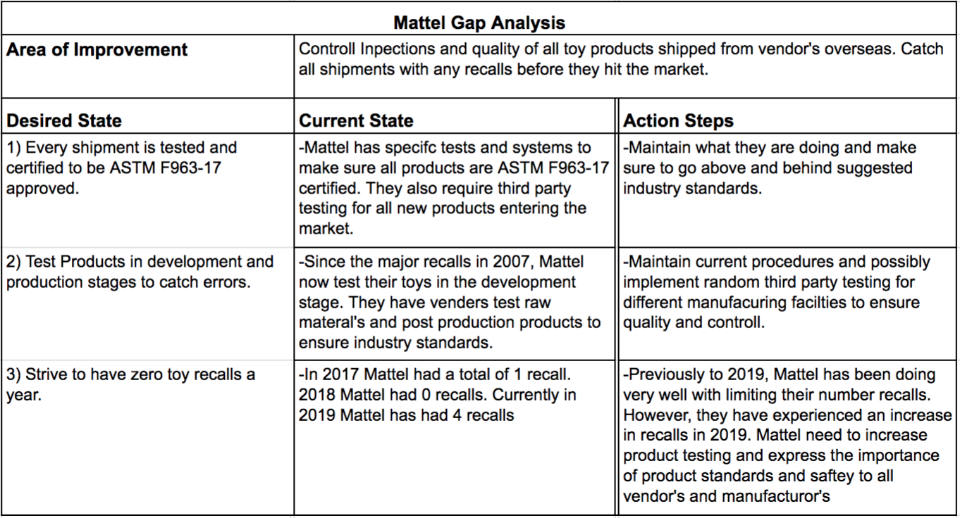

**Current Situation:**

Currently, all toys intended for children 12 and under have to be ASTM F963-17 certified. To do this, third party CPSC-accepted laboratories must test each new toy that a company intends to produce and make sure it's up to industry standards. Since the major recalls in 2007-2008, the Standard Consumer Safety Specifications for Toy Safety has mandated and implemented the Consumer Product Safety Improvement Act (CPSIA) that makes sure overseas vendors and companies are responsible for not following industry standards. When the third party laboratories test new toy products they test things such as surface coatings, stuffing materials, cleanliness of liquids, folding mechanisms & hinges, and etc.

From looking at Figure 1 below, one can see that since the CPSIA Act, the number of the yearly number of recalls in the United States has decreased drastically. This act was designed to put more pressure on toy companies and in result increase, the precautions taken from both vendors and manufacturers and distributors. Not only does this act protect consumers safety but is potentially saving these companies millions of dollars from recalls.

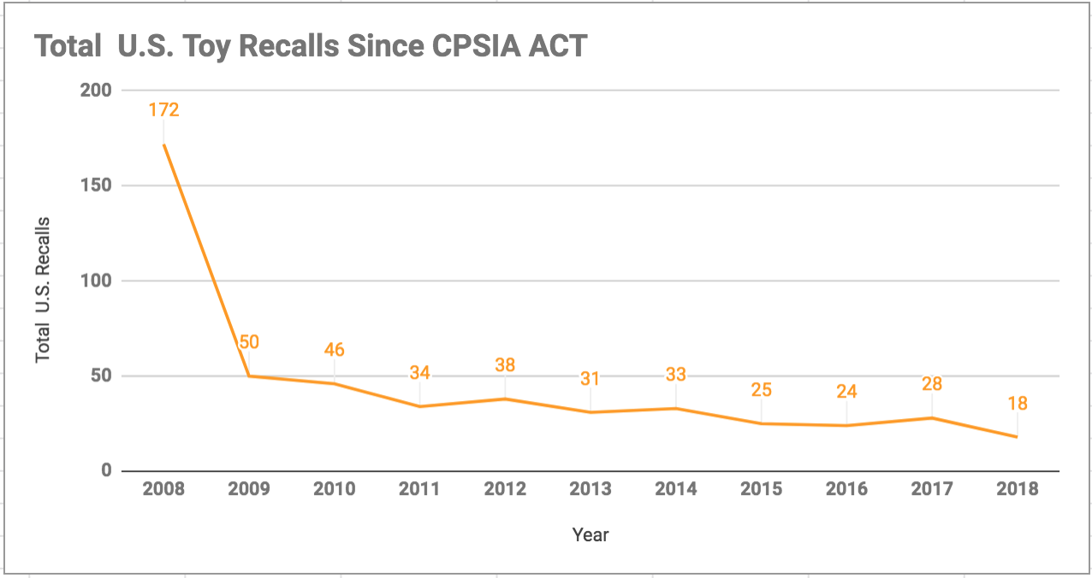

(Figure 1: Total U.S. Toy Recalls Since CPSIA Act)

**Recommended Tools of Operations:**

*Control Charts*

These are graphic presentations of data over time that show upper and lower limits for the process we want to control. Control charts are constructed in such a way that new data can be quickly compared with past performance data. We take samples of the process output and plot the average of each of these samples on a chart that has the limits on it. The upper and lower limits in a control chart can be in units of temperature, pressure, weight, length, and so on.

How Mattel could have used control charts: Mattel could set a standards for quality and measure each lot of toys produced to make sure that their products are in between the desired range.

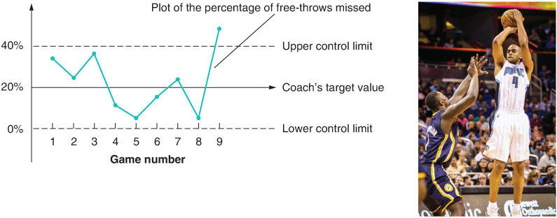

*Pareto Charts*

Pareto charts are a method of organizing errors, problems, or defects to help focus on problem-solving efforts. They are based on the work of Vilfredo Pareto, a 19th-century economist. Joseph M. Juran popularized Pareto’s work when he suggested that 80% of a firm’s problems are a result of only 20% of the causes.How Mattel would use Pareto charts: Using this chart would be useful for Mattel because they would immediately spot the top problems and prepare a plan to address them.

*Poka-yoke Checklists*A type of poka-yoke to help ensure consistency and completeness in carrying out a task. A basic example is a to-do list. If managers of each production line completed a checklist, it would have helped ensure “consistency and completeness in carrying out the development of the said product.” During this time the manager would complete an attribute inspection to classify the lot as either good or defective.

How Mattel can use it: Mattel can use the checklist to sign off shipments to check standards and decrease their overall liability of the product. Venders sign off each shipment that their product meets the standards and hold vendors reliable.

*Acceptance Sampling Method*

This is a form of testing that involves taking random samples of lots and measuring them against the set standards. This alternative is also more economical than 100% inspection. “A lot of items rejected, based on an unacceptable level of defects found in the sample, can (1) be returned to the supplier or (2) be 100% inspected to cull out all defects, with the cost of this screening usually billed to the supplier.”

Mattel could use this form of sampling when the small companies that work for the vendors receive raw materials from different distributors. By conducting random samples of raw material it will locate errors during the very beginning of the operational stage, thus stopping any cross-contamination of raw materials entering the product.

*Statistical Quality Control*

By Mattel building statistical quality controls at the supplier level, they could have no need for acceptance sampling. This would be feasible once they complete a few years of acceptance sampling in order to create a more practical and clean process.

*Factor-Rating Method (for location decisions)*

Develop a list of relevant factors called *key success factors*

1. Assign a weight to each factor to reflect its relative importance in the company’s objectives.
2. Develop a scale for each factor (for example, 1 to 10 or 1 to 100 points).
3. Have management score each location for each factor, using the scale in Step 3.
4. Multiply the score by the weights for each factor and total the score for each location.
5. Make a recommendation based on the maximum point score, considering the results of other quantitative approaches as well

How Mattel can use it: Part of their problem was knowing how many supplies they had. Using this method could have helped keep the vendor's stay within regulations and also keep track of them.

**Recommendation**

1. Mattel should use the acceptance sampling method by first creating a standard that meets the requirements of US regulations of ASTM F963-17 Standard Consumer Safety Specification for Toy Safety. By doing this Mattel will be able to compare their products to the required levels and can detect any faults in their products. When a lot of items is rejected, it can be either returned to the supplier or 100% inspected to cull out all defects. The cost of this would be billed to the supplier for faulty products. This method would decrease the number of recalls, specifically lead, that Mattel has had in the past. This would also keep their suppliers following the correct standards because their defect fee would continue to increase with the number of rejects lots. While the acceptance sampling method can be expensive, it would decrease the number of defaults and unsafe products put to market.
2. The sustainability factor of acceptance sample is for five years due to Mattel building statistical quality controls at the supplier level. This would be feasible once they create a more practical and clean process.

**Work Cited:**

Kavilanz, Parija B. "Mattel fined $2.3 million over lead in toys." CNNMoney. 05 June 2009. Cable News Network.

<https://money.cnn.com/2009/06/05/news/companies/cpsc/> .

Kind, Terry. “Stages of a Toy Recall.” *Archives of Pediatrics & Adolescent Medicine*, vol. 162, no. 4, 2008, p. 390.

“Mattel Recalls Various Barbie® Accessory Toys Due to Violation of Lead Paint Standard.” *U.S. Consumer Product Safety Commission*, 28 May 2017,

[www.cpsc.gov/Recalls/2007/mattel-recalls-various-barbie-accessory-toys-due-to-violation-of-lead-paint-standard](http://www.cpsc.gov/Recalls/2007/mattel-recalls-various-barbie-accessory-toys-due-to-violation-of-lead-paint-standard).

McLaughlin, Joe. "Lead Contaminated Toys Cost Mattel Over $50 Million." Hg.org. <https://www.hg.org/legal-articles/lead-contaminated-toys-cost-mattel-over-50-million-7522> .

Sethi, S. Prakash, et al. “Mattel, Inc.: Global Manufacturing Principles (GMP) – A Life-Cycle Analysis of a Company-Based Code of Conduct in the Toy Industry.” *Journal of Business Ethics*, vol. 99, no. 4, 2010,

Slauson, James. “Mattel.” *The Bloomsbury Encyclopedia of Design*, 2016

“Toy Safety Business Guidance & Small Entity Compliance Guide.” *CPSC.gov*, 10 Apr. 2019, [www.cpsc.gov/Business--Manufacturing/Business-Education/Toy-Safety-Business-Guidance-and-Small-Entity-Compliance-Guide](http://www.cpsc.gov/Business--Manufacturing/Business-Education/Toy-Safety-Business-Guidance-and-Small-Entity-Compliance-Guide)

Story, Louise. "Lead Paint Prompts Mattel to Recall 967,000 Toys." The New York Times. 02 Aug. 2007. The New York Times. <https://www.nytimes.com/2007/08/02/business/02toy.html>.

“Toy Safety Business Guidance & Small Entity Compliance Guide.” *CPSC.gov*, 10 Apr. 2019, [www.cpsc.gov/Business--Manufacturing/Business-Education/Toy-Safety-Business-Guidance-and-Small-Entity-Compliance-Guide](http://www.cpsc.gov/Business--Manufacturing/Business-Education/Toy-Safety-Business-Guidance-and-Small-Entity-Compliance-Guide)

Wearden, Graeme. "Mattel recalls toys over magnet fears." The Guardian. 14 Aug. 2007. Guardian News and Media. <https://www.theguardian.com/business/2007/aug/14/china.usnews1>.