Service Learning Project:

Accelerate

Paige Taylor, TJ Nesbit, Justin Whitehouse, Nathan Karlsen

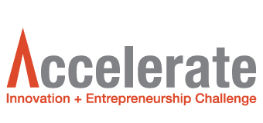

November 28, 2017

Professor Mozill

**Intro**

Accelerate, Wentworth’s Innovation and Entrepreneur Center, has given students the ability to create new ideas and formulate them into a company. However, stigma surrounding what Accelerate is has limited student participation. ~~They~~ Accelerate needs a solution to this dilemma. By ~~create~~ creating <Proofread!!> a marketing proposal that will increase event awareness and attendance ~~they~~ Accelerate will be able to reach and retain a higher quantity of students. Through the use of Dolan’s Schematic of Marketing, Accelerate’s strengths and weaknesses came to light. <Avoid idioms in business writing.> The proposed plan continues to utilize the strengths while diminishing the weaknesses. ~~They have~~ Accelerate has a strong social media presence with frequent posts on all platforms. Accelerate has used many different methods like social media to increase ~~their~~ attendance. By generating more interest in Accelerate, stakeholders will recognize Wentworth as a leader in innovation and entrepreneur mentorship on college campuses in Boston. While Accelerate is successful in mentoring students through their program, few students attend due to the misconception of what Accelerate entails. The proposed plan is to increase attendance by focusing on the freshman class through an event hosted in their residential halls;<New sentence.> Accelerate will be able to accurately communicate to students what their program encompasses.

**About**

Accelerate is a hub for “interdisciplinary, extracurricular programs that aim to build innovative thinking and entrepreneurial confidence in students.” <What is the source of this quote?> The semester long mentorship program, The Startup Challenge, includes four milestones: Kickstarter, Boot Camp, Hot Seat, and Pitch Round. During the Kickstarter milestone students have the chance to network with each other about ideas and problems they have identified. The next milestone, Boot Camp, takes place on weekends and contains multiple presentations over the course of several hours. At this time, teams are assigned an Accelerate coach who are students taking part in Leadership Institute Phase 1. The Hot Seat milestone has teams perfect a 1-minute pitch to quickly and concisely share their projects while students, faculty, and staff ask questions about their product or service. The final milestone, Pitch Round, places students in front of investors; <New sentence.> they ~~must~~ pitch their new company using the information and knowledge gained during the other phases of the program~~. In addition to this program~~, <Delete unnecessary words.>Accelerate ~~also~~ offers students the chance to attend presentations from industry leaders to further their entrepreneurial knowledge in the business world. By completing this program students develop the skills and experience needed to be competitive in their respective fields

**Dolan’s Schematic**

**Marketing Analysis (The 5 C’s)**

Accelerate’s ~~customer’s~~ customers <Plural, not possessive. Proofread!!> require professional guidance and feedback on business innovation strategies and implementation. They provide organized and professional workshops that help to develop student’s entrepreneurial ideas and skills. Companies and clubs that ~~are~~ ~~competitors to~~ compete with Accelerate ~~are~~ include Mass Challenge, MIT Entrepreneurs Club, Harvard Entrepreneurship Club, and the Northeastern Entrepreneurs Club. Although other universities are not competing for Wentworth students <Yes, they do!> they are competing for the success of their ideas ~~as well as~~ and investors.

Accelerate has a plethora <Be careful using this word. It is generally a negative attribute (excess, glut, etc.).> of collaborators including the following: Wentworth Institute of Technology, Mass Innovation Nights, The Capital Network, Office of Business Development City of Boston, and Team Dynamic Boston. <Pitch Round judges, COF schools> These collaborators ~~are vital to the success of the Accelerate program by~~ offer~~ing~~ students networking opportunities and real world experience. Each ~~of these companies has~~ helped Accelerate grow through emotional and financial support. Professors, staff, and students show their appreciation by coming to the events hosted by Accelerate. Some professors provide mentorship through sessions about the business world and their personal experiences. Wentworth provides financial support by keeping these events free for students, staff, and faculty ~~as well as~~ and the equipment and supplies used in creating prototypes and models.

An important contextual component to Accelerate is the economy. The success of student’s ideas are affected by the current economic situation. ~~Today~~, we have a healthy, growing economy so students should not be negatively affected by scarce investors or limited interest due to money. Another contextual component is politics on world issues. Due to differing political beliefs, investors and teams may not see eye to eye <Another idiom.> on a subject and ~~therefore~~ negatively impact Accelerate. Students are ~~also~~ limited by the technological resources available to them. Being a technology university has its advantages against other universities, but there will always be a gap between the technology students have access to and the technological advancements of tomorrow.. <Proofread!!>

**Creating Value**

~~In order~~ to determine the target market audience and product positioning, the market must first be broken up into segments. Since Accelerate works mostly with Wentworth students the market can be divided into several groups. Different segments in the market include: Entrepreneurs in the Boston area, Wentworth students, Northeastern students, and students of other schools in the Boston area.

Accelerate targets Wentworth students of all majors. Accelerate is a way for students to experience what it's like to work ~~in~~ on an interdisciplinary team like they will in the work force. They do this by hosting an environment that builds confidence and provides the tools for success in the business world. Interactive, critical-thinking events provide an engaging hands-on experience that fosters the development of successful business skills.

While Accelerate has many benefits for students, it is an underutilized resource on campus. This is due to the misunderstanding of what Accelerate entails. Most students believe that accelerate is similar to the popular TV show Shark Tank. In this TV show people present their business ideas in an intense atmosphere. Since the show is so publicly viewed many students infer this is what Accelerate is like. <So…How is Accelerate positioned? How is Accelerate different from other WIT clubs or other similar programs at other schools?>

By using the S.A.V.E. analysis process, Accelerate’s business model and the services they provide were evaluated. Accelerate solves ~~student’s~~ students’ <Possessive and plural.> need for an environment dedicated to the innovation of technology <Must it be technological?>. They provide the solution through their semester long program that includes the four milestones previously mentioned.

Accelerate gives students access to the design laboratory to make their ideas into a reality. These creative spaces give access to a wealth of materials and supplies to help create prototypes and models. Accelerate also hosts guest speakers from multiple industries that share their knowledge. This gives students access to a network of working professionals and their advice. Students must go to the hosted events ~~as well as~~ and the design lab to have access to the full benefits of Accelerate. <This is Accelerate’s ACCESS. >

The value of Accelerate is engrained in the program itself. <What does this mean?> Participating in Accelerate has no additional cost, except time to students, only great benefits. <What does this mean?> These benefits include an inspiring environment that focuses on innovation through mentorship with student advisors. This creates a tight knit <Another idiom.> community between students ~~both~~ on and off campus. The value in a community like this is the ~~possibilities~~ possibility <Proofread!!> of networking for the future. ~~By~~ having collaborators be a part of the program~~, it~~ serves ~~not only~~ as a platform for networking ~~but also~~ and grants insight into their respective fields.

Accelerate educates students on the benefits of being a part of an interdisciplinary team through their website. They ~~also~~ utilize social media platforms like Facebook, Twitter, and LinkedIn. By using these outlets, Accelerate keeps students, faculty, and staff up to date on events taking place on campus. To inspire freshman to join Accelerate there are small presentations during WOW Week ~~as well as~~ and classes in the fall semester. These presentations educate the student body on the values and experiences one can have through Accelerate.

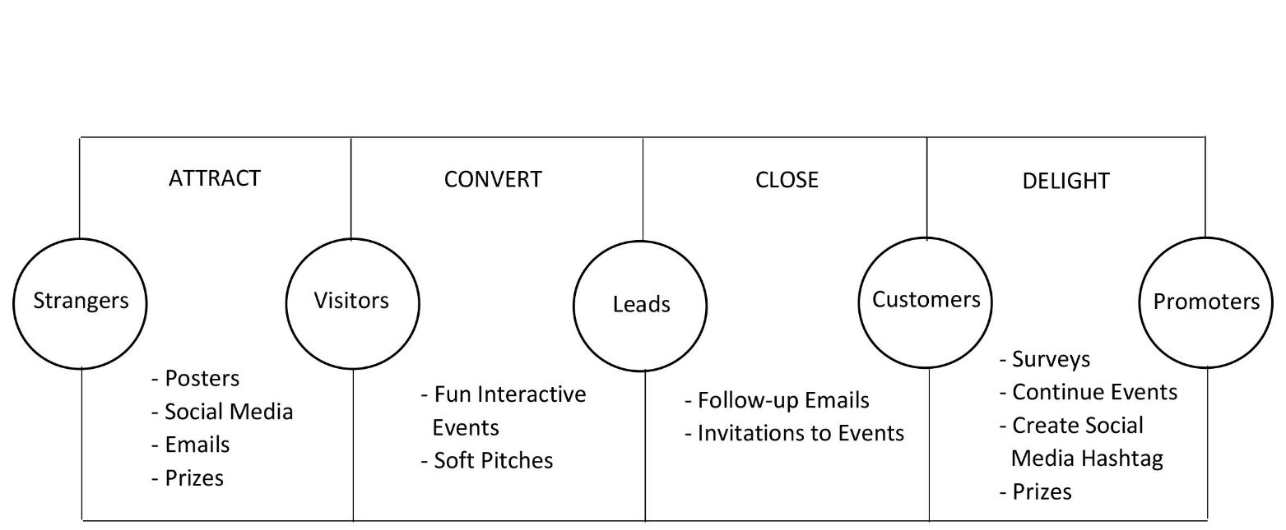**Sustaining Value**

Accelerate uses a wide variety of methods to garner the interest of students~~. As previously mentioned~~, they utilize an active social media presence on both Facebook and Twitter. They also reach students through the campus email ~~which updates students on Accelerate~~. Posters that explain what Accelerate is, their contact information, and their event schedule can ~~also~~ be found posted throughout the university. To retain students, Accelerate provides networking opportunities through their events ~~as well as~~ and mentorship, leadership, scholarship, and fellowship.

**Social Media Strategy**

Social media is an effective tool used by Accelerate that keeps students informed. Posts contain images of events and the progress of team’s development on their product or service. While Accelerate uses many social media platforms, Twitter appears to be <“Appears to be” or ‘is’?> their most popular tool with 1,034 followers. Facebook is the second most active platform with 300 followers. The number of posts are consistent between sites and convey the same message.

**Perceptual Map**

Northeastern

Competitions Entered

<Which end of the axis is high and which is low? How do you define ‘Recognizable Companies’ and ‘Competitions Entered’?>

MIT

Harvard

WIT

Recognizable Companies

Bentley

**Metrics**

Metrics that should be included are the differences in attendance of events before and after implementing the proposed strategy and the overall interest in Accelerate before and after the event. Metrics that should be sought through the use of a survey are a student’s satisfaction, their enjoyment of the event, the likelihood of ~~them~~ attending another event, and becoming involved in Accelerate.

**Stakeholders**

Some relevant stakeholders for Accelerate are students, faculty, alumni, sponsors, collaboration partners, and the Boston community. Students and faculty are Accelerate’s main concern when making decisions since they are what drive the success of the program. The sponsors of Accelerate are important stakeholders as they help with making the events possible. Collaboration partners are vital to supporting Accelerate and providing connections for students to interact with the business world. The Boston community is likely the first place where ~~students~~ students’ <Possessive and plural. Proofread!!> ideas are exposed and their reaction is important to the initial success of the program.

**Strengths & Weaknesses**

While Accelerate is a younger organization on campus, they have had a heavy impact <Another idiom.> on students, faculty, and staff. They ~~have~~ created an environment that encourages students to think beyond their limits. The red walls in their design lab stimulate the brain while providing workspaces and tools necessary to create a company and product. These resources, including the student mentoring program through the Leadership Institute, provide a large network from small businesses to large corporations. ~~Compared to MIT or Harvard, the~~ Accelerate ~~program has an advantage because they~~ does not take any intellectual property. Universities like MIT and Harvard, require ~~that they receive~~ a share of the business and ~~therefore~~ future profits. Accelerate gives the entrepreneur the full benefit of their hard work and dedication; <New sentence.> they only wish to be a catalyst of their success. <The Institute’s official IP is vague on this point.>

Accelerate’s most prominent weakness is the miscommunication about what Accelerate is ~~amongst~~ in the student body. It is often compared to the TV show ‘Shark Tank’ <On page 4, you typed Shark Tank (no quotes). This and other clues indicate that different people typed different paragraphs and one of you pasted different sections together. Am I wrong? You were instructed to submit a report in ‘one voice’. Please reread the assignment instructions for details.> ~~when, in reality, it is incomparable.~~ The TV show displays people showcasing their product to a panel of investors in hopes of receiving funding. Accelerate is different because it mentors participants through many milestones by improving the product ~~as well as~~ and their marketing and business strategies. ~~However~~, because of this misunderstanding, students miss out on this opportunity. Another common misconception about Accelerate is the “intense” atmosphere. According to students, this is due to the intense nature of the TV show. Students believe they are going to be constantly pressured and ridiculed like contestants on the show. These misconceptions likely reduce the probability of someone being interested in joining Accelerate or attending their events.

**Proposal**

The following proposal has been created for Accelerate to increase future event awareness, interest, and involvement. Accelerate currently has 35 teams with a total of 95 students actively participating. Through current trends, it was found that the target audience would be ~~freshman~~ first-year students <Use gender neutral terms.>. This is due to first year students actively searching for new opportunities to meet new people and become a part of something. ~~Once an~~ ~~upperclassman~~ Juniors and seniors, ~~students~~ tend to stay with what they are involved on campus.

Since many of the current Accelerate pitches can make the program seem like an overwhelming task, our proposal hopes to make Accelerate much more approachable and realistic in the minds of students. Due to the large amount of time freshman spend in the dorms, specifically Baker Hall and Evans Way/ Tudbury, it is believed that this would be an ideal location for hosting the event on campus. This would be easily accessible and in a comfortable environment for the students. The residential housing directors and assistants already hold multiple floor events throughout the semester that have high levels of attendance. This is because there is a scholarship opportunity offered if one attends a specific number of events. If Accelerate partners with the housing department, this event could count as one of scholarship events and ensure a high level of student attendance and involvement.

This workshop should be utilized at the beginning of the fall semester each year in freshman housing. The event would start with a ten minute, informal introduction of Accelerate and the instructions for the workshop. After, students would be divided into multiple teams where they are given a potential topic such as homework, Wentworth, or Chartwells. Students will have to brainstorm as many issues as they can on their assigned topics in two minutes. They will then select one issue to resolve. They will have 15-20 minutes to come up with their proposed solution and one minute to give an elevator pitch on their product/ service. After all the groups have presented, the Accelerate team will judge the groups based on the following criteria: organization, practicality, teamwork, and delivery; the winning team will be awarded a prize. At the conclusion of the event, the Accelerate team will deliver its closing remarks and answer any questions.

To promote this workshop, Accelerate must first contact Phillip Bernard, Housing Director, to receive approval. This would ensure the workshop as a scholarship opportunity event. Next, they must speak with the Resident Directors of Evans Way/ Tudbury, Kevin Long, and Baker Hall, Kate Nowak, to ask for permission to use residence hall space to host the workshop. The Resident Assistants would be promoters of the workshop in their floor meetings and count it as one of their events. Other promotional materials would include a prize incentive displayed on posters, emails, social media, and A-frame signs.

**Conclusion**

Through the analysis of Accelerate’s marketing and business strategies, there has been a lack~~ing~~ of student participation within the program. This is due to the many misconceptions about Accelerate. Time, being the only cost, is outweighed by the benefits received from Accelerate. These include a tight knit community, networking opportunities, insights into respective fields, and an innovation driven environment. This gives Accelerate a superior value available to students. By using the proposed workshop, not only will Accelerate’s message become clearer, it will inspire innovative thinking and increase student retention.

4.5/5